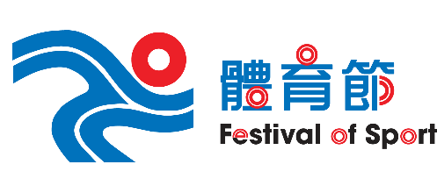 | Organizer | Co-organizer | Subvented by
 | 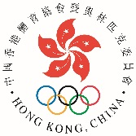 | 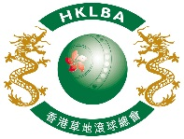 | 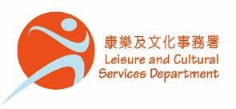

65th Festival of Sport
Aitkenhead Fours Lawn Bowls Competition 2022

The Aitkenhead Fours Lawn Bowls Competition is organized by the Sports Federation & Olympic Committee of Hong Kong, China, co-organized by the Hong Kong Lawn Bowls Association and sub-vented by the Leisure & Cultural Services Department as part of the 65th Festival of Sport.

Date: Saturday 2nd and Sunday 3rd April, 2022.
Contingency: Saturday, 9th and Sunday 10th April, 2022.

Venue: Wu Shan Lawn Bowling Green, Hang Hau Man Kuk Lane Park and Victoria Park
Sport for All全民運動
Entries fee: $400 per team

Entries deadline: Monday 7th March, 2022

Prizes: Winner, Second, Third and Fourth in each gender section

No. of teams and priority of entries: Each member club is guaranteed one entry of each gender. Clubs with more than one team will enter a draw to decide the right to entry. Two teams of each gender from the Hong Kong China Squad will participate in the competition.

Provisional conditions of play extracts: Fours. Two bowls per player. 6 ends per game in sectional and/or knock-out play. Time limit may apply. Jack placed by the Skip on the centre line and not to be delivered by the Lead. Dead jack re-spotted to the 2-metre mark commonly known as the “T”. No head visit. Lead, Second and Third to stay at the mat end before delivery of the Third’s second bowl. Full conditions of play to be issued with the draw and fixtures.

Substitution rules: Only one substitute is allowed in each match. A substitute is not allowed to be Skip in any match irrespective of the number of matches played. A minimum of three of the original players have to play in each match. No team can play with only three players. Players and substitutes in a team may not play in another team.

Uniform: Hong Kong Lawn Bowls Association dress code applies. No exceptions for shoes and other upper or lower body attire.

Subject to the government policy on social distancing measures, participants may need to provide the prove of vaccination or exemption before being allowed to enter the venue and take part in the competition. Any teams who failed to comply with the latest regulations will result in disqualification and be treated as walkover.

By entering the Aitkenhead Fours Lawn Bowls Competition 2022, participants agree to give their consent to the HKLBA to pass their personal data and other related information to the SFOC and any relevant government bodies for the handling of suspected cases of COVID-19 and for the SFOC to use the FOS event photos for advertising or promotional purposes. Personal data and other related information will also be passed to SF&OC for the issuing of e-certificate, sending of SF&OC / FOS promotion materials or other directly related purpose(s).

Enquiries: 2504 8249
 | Organizer | Co-organizer | Subvented by

65th Festival of Sport
Aitkenhead Fours Lawn Bowls Competition 2022

Entries Form
(Club Entries)

Club Convenors are required to email the duly completed entries form in MS Word doc format to competition@hklba.org before the deadline via the club’s registered email address.

For guaranteed entry, maximum of one team each gender per Club.

Club can also enter teams for Open Entries using the additional table below. Club with more than one team will enter a draw to decide the right to entry.

Men Team – guaranteed entry  Player Name Contact No.  1  2  3  4 | Women Team – guaranteed entry  Player Name Contact No.  1  2  3  4

Club Teams for Open Entries – subject to availability after guaranteed entries
Men /  Women | Player 1  Name & Contact No. | Player 2  Name & Contact No. | Player 3  Name & Contact No. | Player 4  Name & Contact No.

Club : Convenor's signature: Date :

