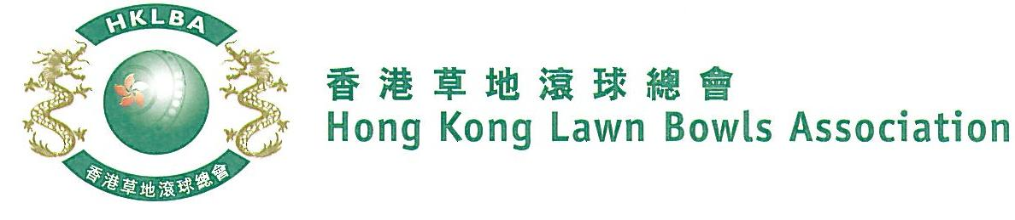

Indian Recreation Club Invitation Triples 2019

The annual Indian Recreation Club Invitation Triples Competition hosted by the Indian Recreation Club is scheduled for Tuesday, 1st October.

This is a one-day tournament of two-bowl triples of any gender and combination, i.e. men only, women only or mixed.

Each club is invited to send one team to join the host IRC teams.

Trophies will be awarded to the winners and runners-up of the “Cup”, “Plate” and “Bowl” by IRC. Lunch and dinner will be provided to all registered players by courtesy of IRC.

Entries deadline is Monday, 16th September 2019. Entries fee is $600 per team.

No replacement of players allowed after the draw. Transfer of players between teams is not allowed after the commencement of the tournament.

Only one substitute per team is allowed in each match. A substitute is not allowed to be skip in any match irrespective of number of matches played. A minimum of two of the original players have to play in each match. No team can play with only two players in any match.

Conditions of play will be issued with the draw.

Club convenors are requested to email the duly completed entries form in MS Word doc format to competition@hklba.org before the deadline via the club’s registered email address.

Lead | Second | Skip | Contact Tel. No.

Player can order additional refreshment coupon at IRC office on 1st October.

Club : _________ Convenor Signature: Date: _____________

