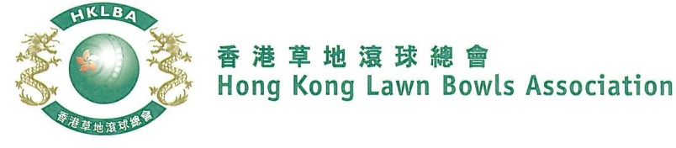
2-4-2 Pairs Competition 2022
A Bowler of the Year Event
Entries Form

The annual 2-4-2 Pairs Competition is scheduled to commence on Thursday, 27th October 2022. Matches will normally be scheduled for the evening session every Thursday. The Finals will be held at the 2022 National Championship Finals Day - Winter.

Format: 15 ends. Details refer to Bye-law 6.17. Either indoor or outdoor green is allowed as home green. Prizes will be awarded to the winner, second and joint thirds.

Dates: 27th October, 3rd, 10th , 17th , 24th November, 1st, 8th and 15th December. Other Thursdays may be used. The National Championships Finals Day - Winter is scheduled to be held on 29th January 2022. Re-scheduling of the Semi-finals and Finals by competitors’ mutual agreement is not permitted.

Entries deadline is Monday, 10th October 2022. Entries fee is $200 per team.
Men’s Entries
Ref. | Player 1 | Player 2  (Contact) | Contact Tel. No. | Home  Green
1
2
3
4
5
6
7
8

Women’s Entries
Ref. | Player 1 | Player 2  (Contact) | Contact Tel. No. | Home  Green
1
2
3
4
5
6
7
8

Enter player name in one of the following formats only. Allow one space between initials with no dots required. Capitalize the first letter of each name.
Example: | Bonnie Chan Wing Yan | Bonnie W Y Chan | Bonnie Chan | W Y Chan

Club Convenors are required to email the duly completed entries form in MS Word doc format to competition@hklba.org before the deadline.

Club : ______________________ Convenor's Signature: ______________ Date : _______________

