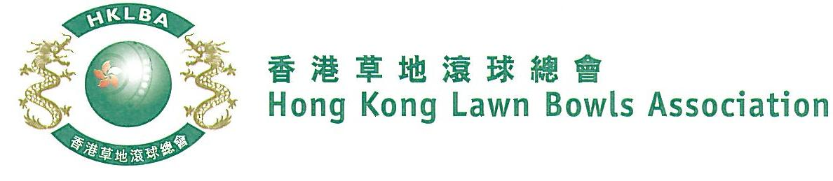
National Indoor Pairs Competition 2021
Entries Form

The National Indoor Pairs Competition is scheduled to commence in July 2021. Semi-finals and Finals will be held on Sunday, 6th February (Sunday). Venue is SBI.

Format: Sets play. Best of two sets of 9 ends, followed by a tie-break of 3 ends if necessary. Three bowls by the Lead, followed by three bowls by the Skip. Re-spotting rule applied. Full conditions of play will be issued with the draw.

Match dates are to be mutually agreed between the teams and notified to the HKLBA as per schedule to be issued with the draw. A tentative schedule is appended below.

Entries deadline is Monday, 19th July 2021. Entries fee is $200 per team. Prizes will be awarded to the winner, second and joint thirds.

Club convenors are requested to email the duly completed entries form in MS Word doc format to competition@hklba.org before the deadline via the club’s registered email address.

Round No. | Tentative Completion Deadline  (To be finalized after close of entries)
Round 1 | 6th September, 2021
Round 2 | 18th October, 2021
Round 3 | 29th November, 2021
Round 4 | 20th December, 2021
Men’s Round 5 / Women’s Quarter-finals | 10th January, 2022
Men’s Quarter-finals | 24th January, 2022
Semi-finals & Finals | 6th February, 2022
National Indoor Pairs Competition 2021
Entries Form

Men’s Entries
Ref. | Player 1 | Player 2  (Contact) | Contact  Tel No | Home Green
1
2
3
4
5
6
7
8
9
10
11
12
13
14
15

Club : _____________ Convenor's Signature: ______________ Date : _______________
National Indoor Pairs Competition 2021
Entries Form

Women’s Entries
Ref. | Player 1 | Player 2  (Contact) | Contact  Tel No | Home Green
1
2
3
4
5
6
7
8
9
10
11
12
13
14
15

Club : _____________ Convenor's Signature: ______________ Date : _______________

