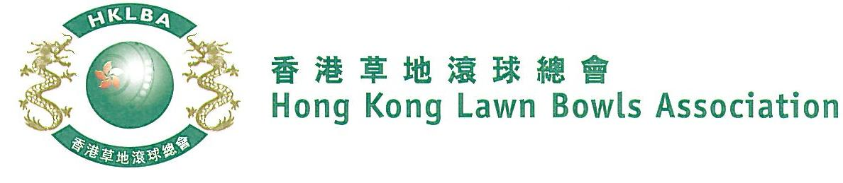
National Indoor Pairs Competition 2022
Entries Form

The National Indoor Pairs Competition is scheduled to commence in July 2022. Semi-finals and Finals will be held on Sunday, 12th February 2023 (Sunday). Venue is TBC.

Format: Sets play. Best of two sets of 9 ends, followed by a tie-break of 3 ends if necessary. Three bowls by the Lead, followed by three bowls by the Skip. Re-spotting rule applied. Full conditions of play will be issued with the draw.

Match dates are to be mutually agreed between the teams and notified to the HKLBA as per schedule to be issued with the draw. A tentative schedule is appended below.

Entries deadline is Monday, 18th July 2022. Entries fee is $200 per team. Prizes will be awarded to the winner, second and joint thirds.

Club convenors are requested to email the duly completed entries form in MS Word doc format to competition@hklba.org before the deadline via the club’s registered email address.

Round No. | Tentative Completion Deadline  (To be finalized after close of entries)
Round 1 | 19th September, 2022
Round 2 | 24th October, 2022
Round 3 | 28th November, 2022
Round 4 | 12th December, 2022
Men’s Round 5 / Women’s Quarter-finals | 2nd January, 2023
Men’s Quarter-finals | 16th January, 2023
Semi-finals & Finals | 12th February 2023
National Indoor Pairs Competition 2022
Entries Form

Men’s Entries
Ref. | Player 1 | Player 2  (Contact) | Contact  Tel No | Home Green
1
2
3
4
5
6
7
8
9
10
11
12
13
14
15

Club : _____________ Convenor's Signature: ______________ Date : _______________
National Indoor Pairs Competition 2022
Entries Form

Women’s Entries
Ref. | Player 1 | Player 2  (Contact) | Contact  Tel No | Home Green
1
2
3
4
5
6
7
8
9
10
11
12
13
14
15

Club : _____________ Convenor's Signature: ______________ Date : _______________

