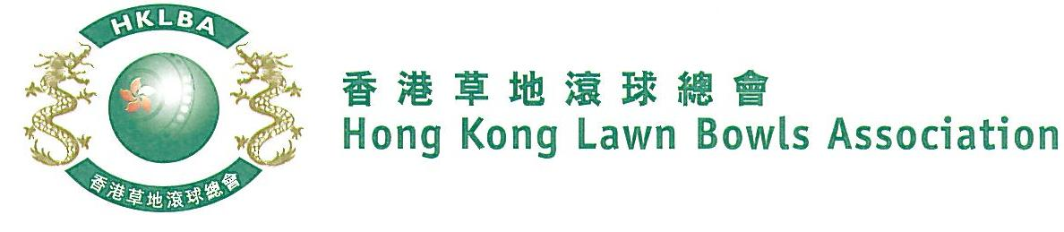
Men’s Knock-out Singles Competition 2022
Sunday, 15th January 2023
Entries Form

The annual Men’s Knock-out Singles Competition is scheduled to be held on Sunday, 15th January, 2023. Fall back day is 26th February, 2023.
Prizes will be awarded to the winner, second and joint thirds. Schedule and conditions of play will be issued with the draw.
Entries deadline is Monday, 5th December 2022. Entries fee is $100 per player.
Club Convenors are required to email the duly completed entries form in MS Word doc format to competition@hklba.org before the deadline.

Ref. | Name | Contact Tel. No.
1
2
3
4
5
6
7
8
9
10
11
12
13
14
15

Club : ______________ Convenor's signature: ______________ Date : __________________

