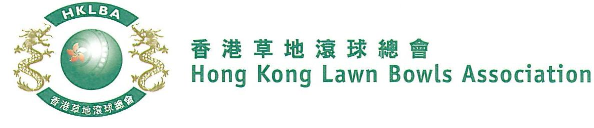
Champion of Champions Championships 2022
The Champion of Champions Championship is scheduled on Saturday and Sunday, 25th February, 26th February, 4th March and 11th March 2023, subject to the availability of greens. Matches may start from 9.00 a.m. on event days. Matches might be re-scheduled to weekday evenings due to unforeseeable circumstances.

Entries are restricted to the current holder of:-
- Champion of Champions Championship
- National Singles Championship
- Knock-out Singles Competition
- Indoor singles Championship
- Under-25 Singles Championship
- Singles Champion of Each Member Club for the Current Season (Clause 6.15 of Bye-laws applies)

Entries deadline is Monday, 16th January, 2023. Entries fee is $250 per player.
Format of sectional round robin play and conditions of play will be issued with the draw.

Name of Club Singles Champion (Men) | Contact Tel. No.

Name of Club Singles Champion (Women) | Contact Tel. No.
** Enter player name in one of the following formats only. Allow one space between initials with no dots required. Capitalize the first letter of each name.

Example: | Bonnie Chan Wing Yan | Bonnie W Y Chan | Bonnie Chan | W Y Chan
Club Convenors are required to email the duly completed entries form in MS Word doc format to competition@hklba.org before the deadline.

Club : _______________ Convenor's Signature: ___________________Date : ___________

