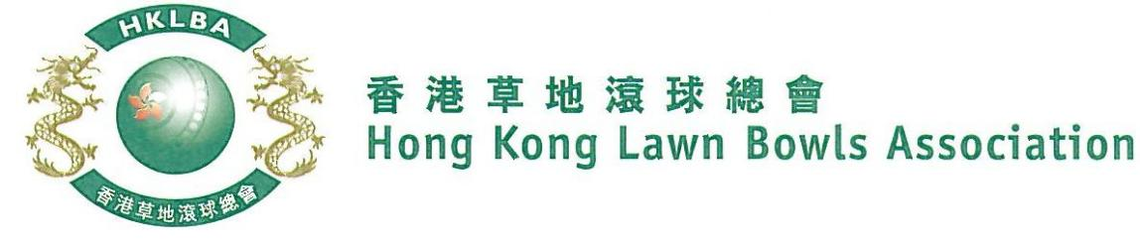
Mixed Fours Competition 2022
Entries Form
The Mixed Fours Competition 2022 is scheduled to commence on 2nd June, 2022. Matches will normally be played on the evening of either Tuesday or Thursday as per schedule. The Finals will be held at the 2022 National Championship Finals Day - Summer.

Format: Two bowls per player, 15 ends. Either Indoor or Outdoor green is allowed as home green.

Tentative dates: 2nd, 16th & 28th June, 5th, 12th, 19th and 26th July. Other Tuesdays & Thursdays may be used. The National Championships Finals Day - Summer is scheduled to be held on 7th August 2022. Re-scheduling of the Semi-finals and Finals by competitors’ mutual agreement is not permitted.

Entries deadline is Monday, 16th May 2022. Entries fee is $400 per team. Prizes will be awarded to the winner, second and joint thirds.

Entries
Ref. | Player 1 | Player 2 | Player 3 | Player 4  (Contact) | Contact Tel. No. | Home Green
1
2
3
4
5
6
7
8
9
10
11
12

Enter player name in one of the following formats only. Allow one space between initials with no dots required. Capitalize the first letter of each name.
Example: | Bonnie Chan Wing Yan | Bonnie W Y Chan | Bonnie Chan | W Y Chan

Club Convenors are required to email the duly completed entries form in MS Word doc format to competition@hklba.org before the deadline.

Club : _____________ Convenor's Signature: ______________ Date : _______________

