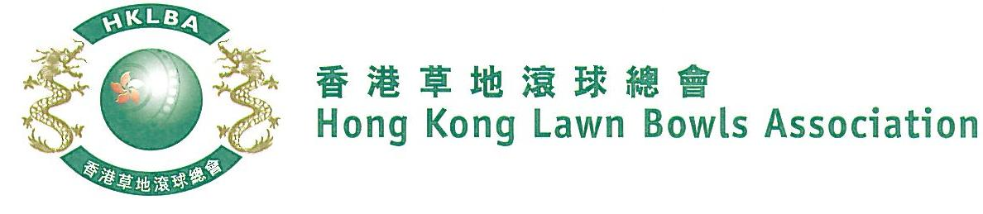
Mixed Pairs Competition 2021
Entries Form

The Mixed Pairs Competition 2021 is scheduled to commence on Tuesday, 13th April 2021. Matches will normally be scheduled for the evening session every Tuesday. The Final will be held at the 2021 National Championship Finals Day - Summer.

Please be aware that as per the LCSD, ALC indoor green will be temporarily unavailable until further notice.

Format: Three bowls per player, 18 ends. Either Indoor or Outdoor green is allowed as home green.

Tentative dates: 13th, 20th, 27th April; 4th, 11th, 18th and 25th May. Other Tuesday evenings may be used. National Championship Finals Day on 1st July 2021. Re-scheduling of the Semi-finals and Final by competitors’ mutual agreement is not permitted.

Entries deadline is Monday, 22nd March 2021. Entries fee is $200 per team. Prizes will be awarded to the winner, second and joint thirds.

Ref. | Lead** | Skip** | Contact Tel No. | Home Green
1
2
3
4
5
6
7
8
9
10
** Enter player name in one of the following formats only. Allow one space between initials with no dots required. Capitalize the first letter of each name.
Example: | Bonnie Chan Wing Yan | Bonnie W Y Chan | Bonnie Chan | W Y Chan
Club convenors are requested to email the duly completed entries form in MS Word doc format to competition@hklba.org before the deadline.
Club : _____________ Convenor's Signature: ______________ Date : _______________

