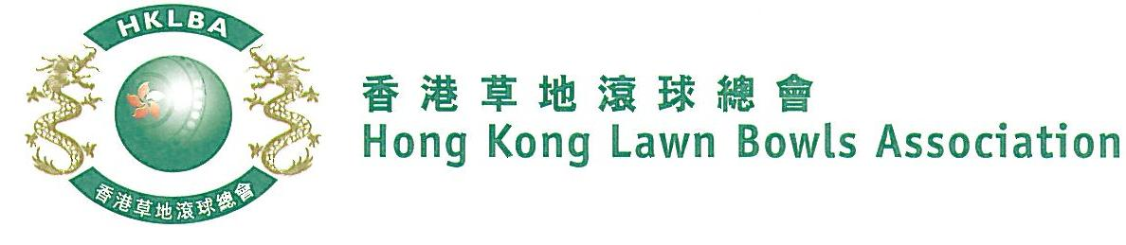
Mixed Pairs Competition 2023
Entries Form

Mixed Pairs Competition 2023 is scheduled to commence on Tuesday, 31st January, 2023. Matches will normally be scheduled for the evening session every Tuesday. Finals will be held at the 2023 National Championship Finals Day - Summer.

Format: Three bowls per player, 18 ends. Either indoor or outdoor green is allowed as home green. Prizes will be awarded to the winner, second and joint thirds.

Tentative dates: 31st January; 7th, 14th, 28th February; 7th, 14th & 21st March 2023. Other mid-week evenings may be used. National Championship Finals Day on Sunday, 25th June 2023. Re-scheduling of the Semi-finals and Finals by competitors’ mutual agreement is not permitted.

Entries deadline is Monday, 9th January, 2023. Entries is $200 per team.

Entries
Ref. | Player 1 | Player 2  (Contact) | Contact Tel. No. | Home Green
1
2
3
4
5
6
7
8
9
10
11
12

Enter player name in one of the following formats only. Allow one space between initials with no dots required. Capitalize the first letter of each name.
Example: | Bonnie Chan Wing Yan | Bonnie W Y Chan | Bonnie Chan | W Y Chan

Club Convenors are required to email the duly completed entries form in MS Word doc format to competition@hklba.org before the deadline.

Club : ________________ Convenor's Signature: _______________________ Date : _______________

