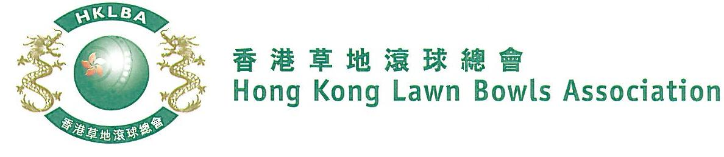
Mixed Triples Competition 2019
Entries Form

The annual Mixed Triples Competition is scheduled to commence on Tuesday, 27th August 2019. Matches will normally be scheduled for the evening session every Tuesday. The Final will be held at the 2019 National Championship Finals Day - Winter.

Format: 2 bowls per player; 18 ends. Either outdoor or indoor green is allowed as home green. Prizes will be awarded to the winner, second and joint thirds.

Tentative dates: 27th August; 3rd, 10th, 17th & 24th September and 15th & 22nd October. Other Tuesday evenings may be used. National Championship Finals Day on Sunday 2nd February 2020. Re-scheduling of the Semi-finals and Finals by competitors’ mutual agreement is not permitted.

Entries: Deadline is Monday, 12th August 2019. Entries fee is $300 per team.

Ref. | Lead ** | Second ** | Skip ** | Contact  Tel No. | Home Green
1
2
3
4
5
6
7
8
9
10
11
12
** Enter player name in one of the following formats only. Allow one space between initials with no dots required. Capitalize the first letter of each name.
Example: | Bonnie Chan Wing Yan | Bonnie W Y Chan | Bonnie Chan | W Y Chan

Club convenors are required to email the duly completed entries form in MS Word doc format to competition@hklba.org before the deadline.

Club : _____________ Convenor's Signature: ______________ Date : _______________

