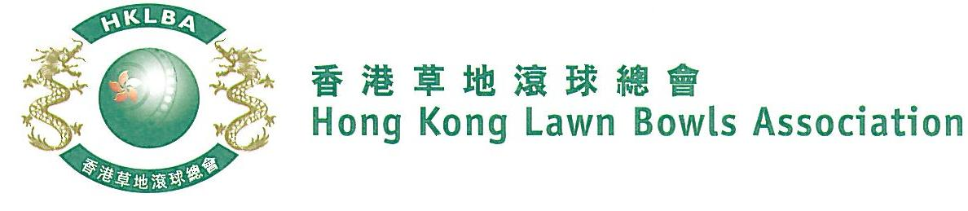
National Pairs Championship 2022
Entries Form

The National Pairs Championship 2022 is scheduled to commence on Sunday, 12th June 2022. Matches in the men’s section will normally be scheduled for the morning session; and women’s section for the afternoon session. The Finals will be held at the 2022 National Championship Finals Day - Summer.

Format: Three bowls per player, 18 ends.
Tentative dates: 12th, 19th, 26th June, 3th, 10th, 17th and 24th July. Other Saturdays and Sundays may be used subject to actual situation. Re-scheduling of the Quarter-finals, Semi-finals and Finals by competitors’ mutual agreement is not permitted.

Entries deadline is Monday, 30th May 2022. Entries fee is $200 per team. Prizes will be awarded to the winner, second and joint thirds.

Men’s Entries
Ref. | Player 1** | Player 2**  (Contact) | Contact Tel. No. | Home Green  (Outdoor)
1
2
3
4
5
6
7
8
9
Women’s Entries
Ref. | Player 1** | Player 2**  (Contact) | Contact Tel. No. | Home Green  (Outdoor)
1
2
3
4
5
6
7
8
9

** Enter player name in one of the following formats only. Allow one space between initials with no dots required. Capitalize the first letter of each name.
Example: | Bonnie Chan Wing Yan | Bonnie W Y Chan | Bonnie Chan | W Y Chan

Club convenors are requested to email the duly completed entries form in MS Word doc format to competition@hklba.org before the deadline.

Club : _____________ Convenor's Signature: ______________ Date : _______________

