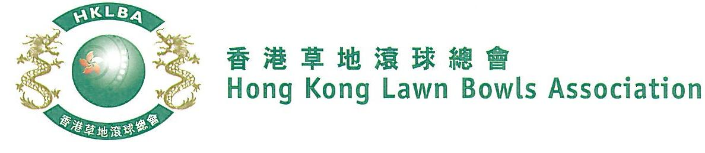
National Triples Championship 2022
A Bowler of the Year Event
Entries Form
The National Triples Championship 2022 is scheduled to commence on Sunday, 9th October 2022. Matches in the men’s section will normally be scheduled for the afternoon session, and women’s section for the morning session. The Finals will be held at the 2022 National Championship Finals Day.

Format: Two bowls per player, 18 ends.
Tentative dates: 9th, 16th, 23th October, 6th, 13th, 20th November, 11th December 2022 and 8th January 2023. Other Sundays may be used subject to actual situation. Re-scheduling of the Quarter-finals, Semi-finals and Finals by competitors’ mutual agreement is not permitted.

Entries deadline is Monday, 19th September, 2022. Entries fee is $300 per team. Prizes will be awarded to the winner, second and joint thirds.

Women’s Entries
Ref. | Player 1 | Player 2 | Player 3  (Contact) | Contact  Tel. No. | Home Green  (Outdoor)
1
2
3
4
5
6
7
8
9
10
Men’s Entries
Ref. | Player 1 | Player 2 | Player 3  (Contact) | Contact  Tel. No. | Home Green  (Outdoor)
1
2
3
4
5
6
7
8
9
10
Enter player name in one of the following formats only. Allow one space between initials with no dots required. Capitalize the first letter of each name.
Example: | Bonnie Chan Wing Yan | Bonnie W Y Chan | Bonnie Chan | W Y Chan

Club Convenors are required to email the duly completed entries form in MS Word doc format to competition@hklba.org before the deadline.

Club : _____________ Convenor's Signature: ______________ Date : _______________

