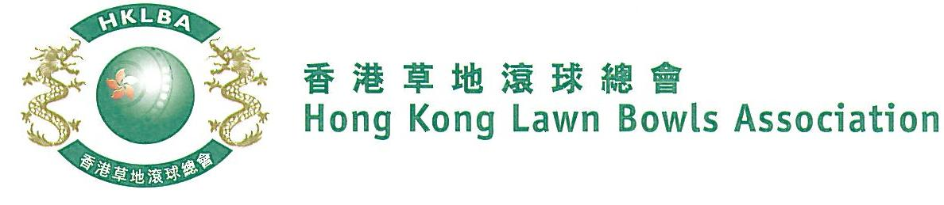
Novice Pairs Competition 2022
Entries Form

Novice Pairs Competition 2022 is scheduled to commence on Thursday, 8th September, 2022. Matches will normally be scheduled for the evening session every Thursday. Finals will be held at the 2022 National Championship Finals Day - Winter.

Format: Three bowls per player, 18 ends. Either indoor or outdoor green is allowed as home green. Prizes will be awarded to the winner, second and joint thirds.

Tentative dates: 8th, 15th, 22nd, 29th September, 6th, 13th, 20th, 27th October 2022. Other mid-week evenings may be used. National Championship Finals Day on Sunday, 29th January 2023. Re-scheduling of the Semi-finals and Finals by competitors’ mutual agreement is not permitted.

Entries deadline is Monday, 29th August, 2022. Entries is $200 per team.

Entries shall be restricted to persons who have not won any open competition approved by World Bowls or any national competition included in Bye-law 6.1.c.(i) to (xxi).
Men’s Entries
Ref. | Player 1 | Player 2  (Contact) | Contact Tel. No. | Home Green
1
2
3
4
5
6
7
8
Women’s Entries
Ref. | Player 1 | Player 2  (Contact) | Contact Tel. No. | Home Green
1
2
3
4
5
6
7
8

Club convenors are requested to email the duly completed entries form in MS Word doc format to competition@hklba.org before the deadline.

Club : ________________ Convenor's Signature: _______________________ Date : _______________

