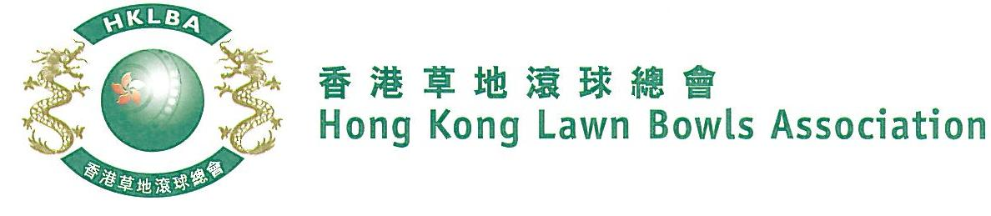
Novice Singles Competition 2021
Entries Form
The Novice Singles Competition 2021 is scheduled to commence on Thursday, 15th April, 2021. Matches will normally be scheduled for the evening session every Thursday. The Final will be held at the 2021 National Championship Finals Day - Summer.

Please be aware that as per the LCSD, ALC indoor green will be temporarily unavailable until further notice.

Format: Four bowls per player, first up to 21. Either Indoor or Outdoor green is allowed as home green.

Tentative dates: 15th, 22nd, 29th April; 6th, 13th and 20th May. Other Thursdays may be used. National Championship Finals Day on 1st July 2021. Re-scheduling of the Semi-finals and Final by competitors’ mutual agreement is not permitted.

Entries deadline is Monday, 22nd March 2021. Entries fee is $100 per player. Prizes will be awarded to the winner, second and joint thirds.

Entries shall be restricted to persons who have not won any open international competition approved by World Bowls or any national competition included in Bye-law 6.1.c.(i) to (xvii).

Men’s Entries
Ref | Name | Contact  Tel. No. | Home Green |  | Ref | Name | Contact  Tel. No. | Home Green
1 |  |  |  |  | 6
2 |  |  |  |  | 7
3 |  |  |  |  | 8
4 |  |  |  |  | 9
5 |  |  |  |  | 10

Women’s Entries
Ref | Name | Contact  Tel. No. | Home  Green |  | Ref | Name | Contact  Tel. No. | Home  Green
1 |  |  |  |  | 6
2 |  |  |  |  | 7
3 |  |  |  |  | 8
4 |  |  |  |  | 9
5 |  |  |  |  | 10
** Enter player name in one of the following formats only. Allow one space between initials with no dots required. Capitalize the first letter of each name.
Example: | Bonnie Chan Wing Yan | Bonnie W Y Chan | Bonnie Chan | W Y Chan

Club convenors are requested to email the duly completed entries form in MS Word doc format to competition@hklba.org before the deadline.

Club : ______________________ Convenor's Signature: ______________ Date : _______________

