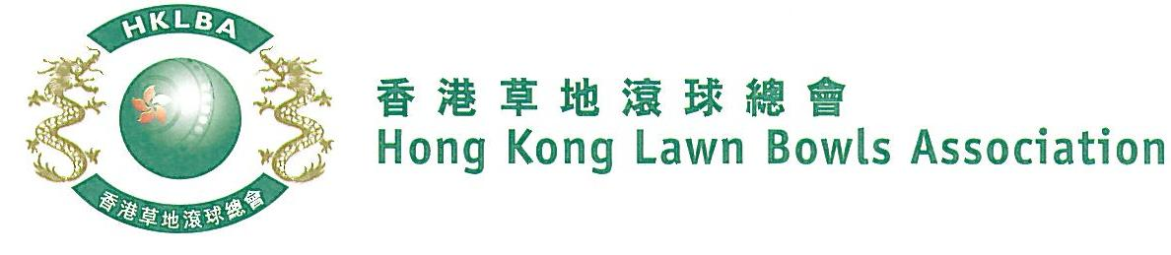
Women’s Knock-out Singles Competition 2022
Sunday, 18th December 2022
Entries Form

The annual Women’s Knock-out Singles Competition is scheduled to be held on Sunday, 18th December, 2022. Fall back day is 19th February, 2023.
Prizes will be awarded to the winner, second and joint thirds. Schedule and conditions of play will be issued with the draw.
Entries deadline is Monday, 21st November 2022. Entries fee is $100 per player.
Club Convenors are required to email the duly completed entries form in MS Word doc format to competition@hklba.org before the deadline.

Ref. | Name | Contact Tel. No.
1
2
3
4
5
6
7
8
9
10
11
12
13
14
15

Club : ______________ Convenor's signature: ______________ Date : __________________

