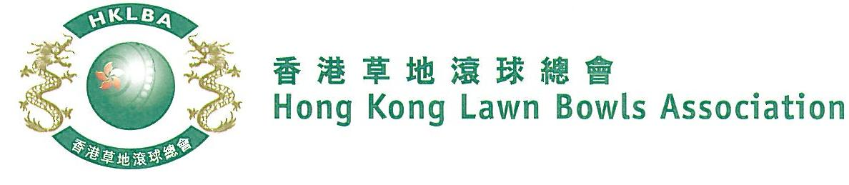
Weekday Fours Competition 2019
Entries Form

Weekday Fours Competition 2019 is scheduled to commence on Wednesday, 27th March, 2019. Matches will normally be scheduled for the afternoon session every Wednesday. Finals will be held at the 2019 National Championship Finals Day - Summer.

Format: The Fours competition will be played in single knock-out format, two bowls per player and 15 ends for each game. Teams with any gender or combination are allowed. i.e. men only, women only or mixed. Either Indoor or Outdoor green is allowed as home green. Prizes will be awarded to the winner, second and joint thirds.

Tentative dates: 27th Mar; 3rd, 17th, 24th April and 8th May. Other weekdays afternoon may also be used. National Championship Finals Day was tentatively scheduled for Sunday, 1st July, 2019. Re-scheduling of the Semi-finals and Finals by competitors’ mutual agreement is not permitted.

Entries deadline is 11th March, 2019 (Mon). Entries fee is $400 per team.
Entries
Ref. | Lead | Second | Third | Skip | Contact  Tel. No. | Home Green
1
2
3
4
5
6
7
8
9
10

** Enter player name in one of the following formats only. Allow one space between initials with no dots required. Capitalize the first letter of each name.
Example: | Bonnie Chan Wing Yan | Bonnie W Y Chan | Bonnie Chan | W Y Chan

Club convenors are requested to email the duly completed entries form in MS Word doc format to competition@hklba.org before the deadline.

Club : _______________ Convenor's Signature: ________________ Date : _____________

