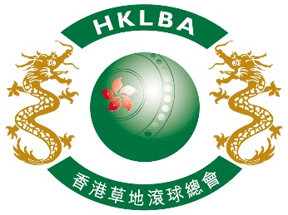

INTENT TO ENTER FORM

Hong Kong International Bowls Classic Carnival 2018

Please complete and return this form to HKLBA office by email (ase1@hklba.org)

on or before 22 June 2018.

ASSOCIATION / CLUB (please print)

On behalf of the above named Association / Club, I hereby confirm the intention to enter

number of Team(s) to the Hong Kong International Bowls Classic Carnival 2018

to be held in Hong Kong from 7 to 13 November 2018.

Contact person | :
Contact email | :
Date | :

