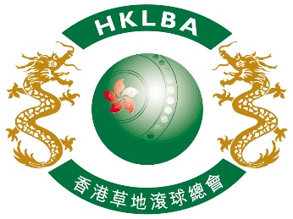

INTENT TO ENTER FORM

Hong Kong International Bowls Classic Carnival 2019

Please complete and return this form to HKLBA office by email (ase1@hklba.org)

on or before 17 July 2019.

ASSOCIATION / CLUB | (please print)

On behalf of the above Association / Club, I hereby confirm the intention to enter

number of Team(s) to the Hong Kong International Bowls Classic Carnival 2019

to be held in Hong Kong from 6 to 12 November 2019.

Contact Person:
Contact Email:
Date:

