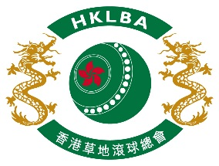 | HKLBA  Annual Presentation Dinner  Friday 25 May 2018

The HKLBA annual presentation dinner will be held at 7:30 p.m. on Friday 25 May 2018 at the Choi Fook Royal Banquet彩福皇宴 (13/F, Auto Plaza, Tsim Sha Tsui East (near Tsim Sha Tsui MTR Station Exit P / 尖沙咀麼地道65號安達中心13/F (鄰近港鐵尖東站P出口). It costs $400 per person. Clubs could either reserve one table for 12 persons or half table for 6 persons. The Association urges for the participation of all prize winners.

10 nos. of tables will be provided for Mah Jong playing from 4:30 p.m. to 7 p.m.. Clubs must
book through HKLBA office in advance.

This form must be returned to the HKLBA office either by Fax (2577 5621) or E-mail : hklba@hklba.org on or before Thursday 19 April 2018. Places will be offered on a FIRST COME FIRST SERVED basis.

Name |  | Name
1 |  | 13
2 |  | 14
3 |  | 15
4 |  | 16
5 |  | 17
6 |  | 18
7 |  | 19
8 |  | 20
9 |  | 21
10 |  | 22
11 |  | 23
12 |  | 24

Remarks : Full cost will be charged for no show.

Total : $400 x persons = $ No. of Tables for Mah Jong playing :

Contact person : (Tel : )

Club : Date :

