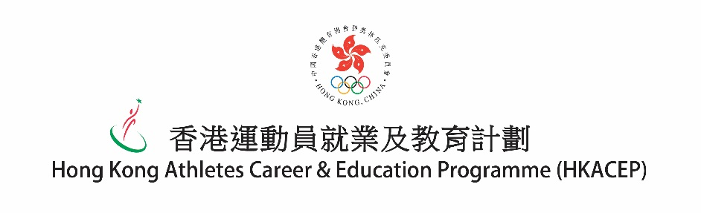
Ref. No
檔案編號:

「星星伴轉型」學長計劃 - 學員申請表
“Stars to Shine” Mentorship Programme – Mentee Application Form

請於2018年4月3日前，將填妥之申請表傳真至2890-9599或電郵至hkacep@hkolympic.org
Please submit the completed application form to HKACEP on or before 3 April 2018 by fax 2890-9599 or via email hkacep@hkolympic.org.

- 個人資料 Personal Particulars

姓名 (英文) 姓名 (中文) 性別
Name in English: Name in Chinese: Sex:

電話號碼 電郵
Contact No.: Email:

所屬體育總會
National Sports Association:

退役年份 (月月/年年) 現職
Retired in (MM/YY): Current Occupation:

- 事業發展意向 Preference of career development

請按興趣選擇3個行業，並在相關□內填上「1」、「2」及「3」(最感興趣請填「1」)以便安排。
Please select and rank 3 most interested careers by marking “1”, “2” and “3” respectively for arrangement purpose.
 | □ 運動行政 (黃金寶先生)  Sports Administration (Mr. WONG Kam Po)  □ 投資銀行界別 (李一強博士)  Financial Services (Dr. Adam LEE)  □ 教育及公益事務 (陳念慈女士)  Education & Charity Affairs (Ms. Amy CHAN)  □ 紀律部隊 (余心怡先生)  Disciplinary Force (Mr. Samuel YU)  □ 其他，請註明:  Others，Please specify:_____________________ | □ 地產發展行政 (鄭家豪先生)  Executive – Property Development (Mr. CHENG Ka Ho)  □ 零售業務營運及管理 (倪文玲女士)  Retail Operations and Management (Ms. Malina NGAI)  □ 電視體育賽事評述 (崔錦棠先生)  TV Sports Commentator (Mr. Tony CHUI)  □ 公關及活動推廣 (李穎詩女士)  Public Relations and Events Management (Ms. Vivian LEE)

- 承諾 Undertaking
本人明白及同意中國香港體育協會暨奧林匹克委員會(港協暨奧委會)有權使用本人於活動期間被拍攝所得之相片及錄像，並擁有有關相片及錄像所涉及的一切權利，包括編訂、刊登或以任何方式使用有關資料的權利。
I understand and agree that Sports Federation & Olympic Committee of Hong Kong, China (SF&OC) owns the rights in utilizing the photos and videos taken during the programme, and owns all rights in and arising from these photos and videos, including editing, publishing or using in other ways.

本人明白及同意遵守由香港運動員就業及教育計劃為「星星伴轉型」學長計劃所訂之一切守則，包括盡力參與活動、積極主動和學長保持聯絡、尊重及珍惜向學長學習的機會、以及於計劃完結前提供最少一篇與學長交流的感想及照片和拍攝一段短片作為總結計劃及宣傳之用。
I understand and commit to all the rules and guidelines of the “Stars to Shine” Mentorship Programme set by Hong Kong Athletes Career & Education Programme (HKACEP), including but not limited to devotedly participating all the events organised by HKACEP, proactively keeping contact with the assigned mentor as well as to provide at least one piece of self-reflection sharing article with photos and to take a short video for thanking the mentor towards the end of the programme as well as for promotional use.

本人為自願參與此計劃，接受並服從HKACEP就「星星伴轉型」學長計劃的一切安排。
I accept and will adhere to all arrangements of HKACEP for the programme.

本人明白作為「星星伴轉型」學長計劃之學員，本人有義務尊重及維持港協暨奧委會之正面形象。
I understand that being the mentee of the “Stars to Shine” Mentorship Programme, I have an obligation to respect and maintain the positive image of SF&OC.

申請人簽署 Applicant’s Signature | 日期 Date
監護人簽署(如適用) Guardian’s Signature (If applicable) | 日期 Date

