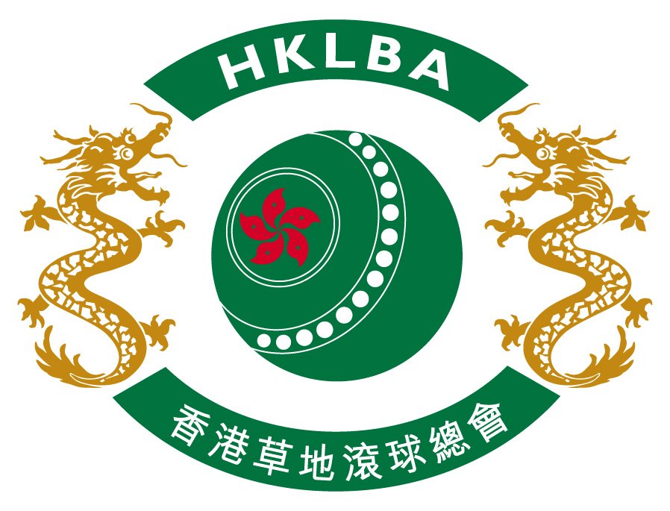

CCC 120th Anniversary Hong Kong International Bowls Classic 2014

PRESENTATION DINNER
(Sunday 16 November 2014 at CCC)

This popular event will be held on Sunday 16 November 2014 at the Dragon Room of Craigengower Cricket Club (CCC) commencing at 6:30 p.m. after the Pairs Final. The cost for the dinner will be $350 per person.

If you would like to attend please enter your name(s) below and return this sheet to HKLBA office no later than Friday 31 October 2014.

Please note that ONLY Classic Pairs players and Singles medalists will be given free tickets to the Presentation dinner. Classic Singles players are to be entered under your Club's list here if you wish to join the Presentation Dinner.

1. | 6.
2. | 7.
3. | 8.
4. | 9.
5. | 10.

Club : Contact Person : Tel :

Total cost : HK$350 x person(s) = HK$

