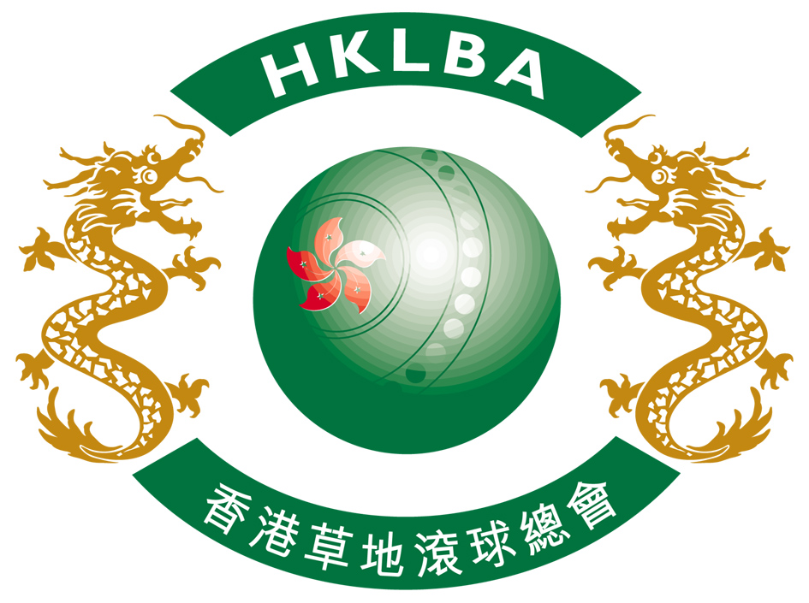

INTENT TO ENTER FORM

Hong Kong International Bowls Classic Carnival 2016

Please complete and return this form to HKLBA office by email at howard@hklba.org

on or before 19 June 2016.

ASSOCIATION / CLUB (please print)

On behalf of the above named Association / Club, I hereby confirm the intention to enter

number of Team(s) to the Hong Kong International Bowls Classic Carnival 2016

to be held in Hong Kong from 2 to 8 November 2016.

Contact person | :
Contact email | :
Date | :

