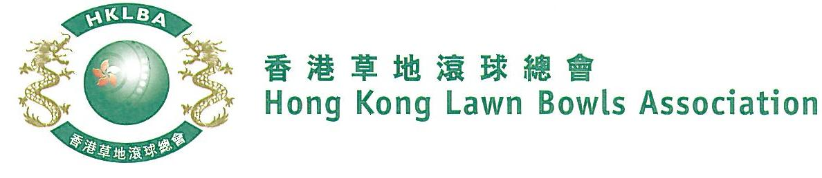
National Indoor Singles Championship 2020
Entries Form

The National Indoor Singles Championship is scheduled to commence in January 2020. Semi-finals and Final will be held at Hong Kong Football Club (HKFC) on Saturday, 11th July 2020.

Format: 4 bowls per player. Set play; each match will consist of two sets of 9 ends; followed by a tie-break if necessary. Full conditions of play to be issued with the draw.

Match dates are to be mutually agreed between the players and notified to the HKLBA as per schedule to be issued with the draw. A tentative schedule is appended below.

Entries deadline is Monday, 13th January 2020. Entries fee is $100. Prizes will be awarded to the winner, second and joint thirds.

Round No. | Tentative Completion Deadline  (To be finalized after close of Entries)
Round 1 | 4 March
Round 2 | 1 April
Round 3 | 29 April
Round 4 | 20 May
Round 5 / Women’s Quarter-finals | 10 June
Men’s Quarter-finals | 1 July
Semi-finals & Final | 11 July at HKFC

National Indoor Singles Championship 2020

Women’s Entries
Ref | Name | Home green | Telephone Number
1
2
3
4
5
6
7
8
9
10
11
12
13
14
15

** Enter player name in one of the following formats only. Allow one space between initials with no dots required. Capitalize the first letter of each name.
Example: | Bonnie Chan Wing Yan | Bonnie W Y Chan | Bonnie Chan | W Y Chan

Club convenors are requested to email the duly completed entries form in MS Word doc format to competition@hklba.org before the deadline via the club’s registered email address.

Club : ___________ Convenor's signature: _________________ Date : _____________
National Indoor Singles Championship 2020

Men’s Entries
Ref | Name | Home green | Telephone Number
1
2
3
4
5
6
7
8
9
10
11
12
13
14
15

** Enter player name in one of the following formats only. Allow one space between initials with no dots required. Capitalize the first letter of each name.
Example: | Bonnie Chan Wing Yan | Bonnie W Y Chan | Bonnie Chan | W Y Chan

Club convenors are requested to email the duly completed entries form in MS Word doc format to competition@hklba.org before the deadline via the club’s registered email address.

Club : ___________ Convenor's signature: _________________ Date : _____________

