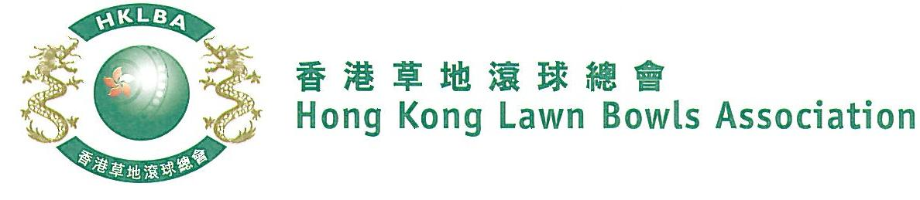

National Fours Championship 2020
A Bowler of the Year Event
Entries Form
The National Fours Championship 2020 is scheduled to commence on Sunday, 3rd May 2020. Matches in the men’s section will normally be scheduled for the afternoon session, and women’s section for the morning session. The Finals will be held at the 2020 National Championship Finals Day - Summer.

Format: Two bowls per player, 18 ends.

Tentative dates: 3rd, 10th, 17th, 24th, 31st May and 7th, 14th, 21st June. Other Sundays may be used. National Championship Finals Day on 28th June, 2020. Re-scheduling of the Quarter-finals, Semi-finals and Finals by competitors’ mutual agreement is not permitted.

Entries deadline is Monday, 6th April 2020. Entries fee is $400 per team. Prizes will be awarded to the winner, second and joint thirds.

Women’s Entries
Ref. | Lead | Second | Third | Skip | Contact  Tel. No. | Home Green  (Outdoor)
1
2
3
4
5
6
7
8
Men’s Entries
Ref. | Lead | Second | Third | Skip | Contact  Tel. No. | Home Green  (Outdoor)
1
2
3
4
5
6
7
8

Enter player name in one of the following formats only. Allow one space between initials with no dots required. Capitalize the first letter of each name.
Example: | Bonnie Chan Wing Yan | Bonnie W Y Chan | Bonnie Chan | W Y Chan

Club convenors are requested to email the duly completed entries form in MS Word doc format to competition@hklba.org before the deadline.

Club : _____________ Convenor's Signature: ______________ Date : _______________

