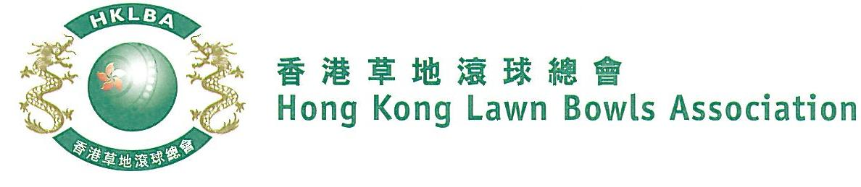

National Fours Championship 2021
A Bowler of the Year Event
Entries Form
The National Fours Championship 2021 is scheduled to commence on Sunday, 27th June 2021. Matches in the men’s section will normally be scheduled for the morning session, and women’s section for the afternoon session. The Finals will be held at the 2021 National Championship Finals Day - Winter.

Format: Two bowls per player, 18 ends.

Tentative dates: 27th June, 15th, 29th August, 5th and 12th September. Other Sundays may be used. National Championship Finals Day on 19th December, 2021. Re-scheduling of the Quarter-finals, Semi-finals and Finals by competitors’ mutual agreement is not permitted.

Entries deadline is Monday, 31st May 2021. Entries fee is $400 per team. Prizes will be awarded to the winner, second and joint thirds.

Women’s Entries
Ref. | Player 1 | Player 2 | Player 3 | Player 4  (Contact) | Contact  Tel. No. | Home Green  (Outdoor)
1
2
3
4
5
6
7
8
Men’s Entries
Ref. | Player 1 | Player 2 | Player 3 | Player 4  (Contact) | Contact  Tel. No. | Home Green  (Outdoor)
1
2
3
4
5
6
7
8

Enter player name in one of the following formats only. Allow one space between initials with no dots required. Capitalize the first letter of each name.
Example: | Bonnie Chan Wing Yan | Bonnie W Y Chan | Bonnie Chan | W Y Chan

Club convenors are requested to email the duly completed entries form in MS Word doc format to competition@hklba.org before the deadline.

Club : _____________ Convenor's Signature: ______________ Date : _______________

