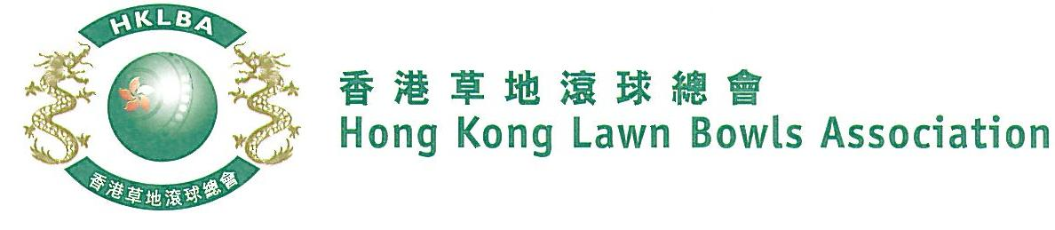
National Pairs Championship 2021
Entries Form
Issued on 3rd February, 2021
The National Pairs Championship 2021 is scheduled to commence on Sunday, 7th March 2021. Matches in the men’s section will normally be scheduled for the afternoon session; and women’s section for the morning session. The Finals will be held at the 2021 National Championship Finals Day - Summer.

Format: Three bowls per player, 18 ends.
Tentative dates: 7th, 14th, 21st, 28th March, 4th, 11th, 18th, 25th April and 2nd May. Other Saturdays and Sundays may be used subject to actual situation. Re-scheduling of the Quarter-finals, Semi-finals and Finals by competitors’ mutual agreement is not permitted.

Entries deadline is Tuesday, 9th February 2021. Entries fee is $200 per team. Prizes will be awarded to the winner, second and joint thirds.

Men’s Entries
Ref. | Lead** | Skip** | Contact Tel. No. | Home Green  (Outdoor)
1
2
3
4
5
6
7
8
9
Women’s Entries
Ref. | Lead** | Skip** | Contact Tel. No. | Home Green  (Outdoor)
1
2
3
4
5
6
7
8
9

** Enter player name in one of the following formats only. Allow one space between initials with no dots required. Capitalize the first letter of each name.
Example: | Bonnie Chan Wing Yan | Bonnie W Y Chan | Bonnie Chan | W Y Chan

Club convenors are requested to email the duly completed entries form in MS Word doc format to competition@hklba.org before the deadline.

Club : _____________ Convenor's Signature: ______________ Date : _______________

