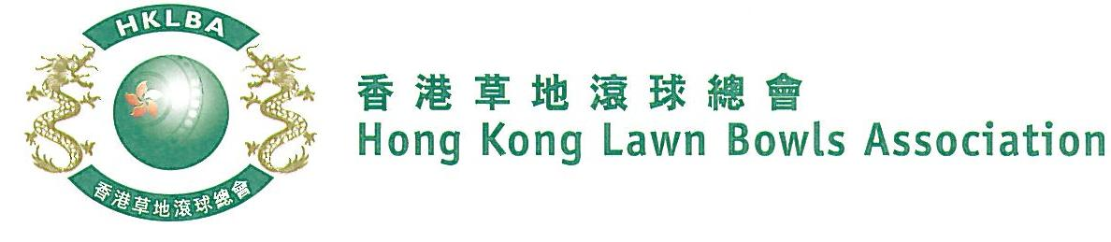
National Triples Championship 2019
A Bowler of the Year Event
Entries Form
The National Triples Championship 2019 is scheduled to commence on Sunday, 18th August 2019. Matches in the men’s section will normally be scheduled for the morning session, and women’s section for the afternoon session. The Finals will be held at the 2019 National Championship Finals Day - Winter.

Format: Two bowls per player, 18 ends.

Tentative dates: 18th and 25th August; 1st, 8th, 15th, 22nd and 29th September. Other Sundays may be used. National Championship Finals Day on 2nd February, 2020. Re-scheduling of the Quarter-finals, Semi-finals and Finals by competitors’ mutual agreement is not permitted.

Entries deadline is Monday, 29th July, 2019. Entries fee is $300 per team. Prizes will be awarded to the winner, second and joint thirds.

Women’s Entries
Ref. | Lead | Second | Skip | Contact  Tel. No. | Home Green  (Outdoor)
1
2
3
4
5
6
7
8
Men’s Entries
Ref. | Lead | Second | Skip | Contact  Tel. No. | Home Green  (Outdoor)
1
2
3
4
5
6
7
8

Enter player name in one of the following formats only. Allow one space between initials with no dots required. Capitalize the first letter of each name.
Example: | Bonnie Chan Wing Yan | Bonnie W Y Chan | Bonnie Chan | W Y Chan

Club convenors are requested to email the duly completed entries form in MS Word doc format to competition@hklba.org before the deadline.

Club : _____________ Convenor's Signature: ______________ Date : _______________

